**Lesson 6 Demo 1**

**Selenium WebDriver Installation and Integration in Eclipse**



Steps to be followed:

1. Install JDK 1.8

sudo apt-get install openjdk-8-jdk

1. Download and setup Selenium server
2. Downloading ChromeDriver
3. Integrating selenium to Eclipse

**Step 1: Download and setup Selenium server**

1.1 Locate selenium using ***locate selenium*** command. If it is not present, then use the following command to update the packages.

***sudo apt-get update***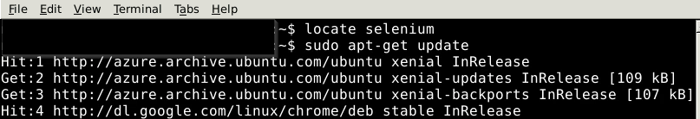

1.2 Install selenium using below command:

***sudo pip install selenium***



1.3 Download selenium standalone server:

<https://github.com/SeleniumHQ/selenium/releases/download/selenium-3.13.0/selenium-server-standalone-3.13.0.jar>

Now you can see the selenium server in the downloads section of your system.

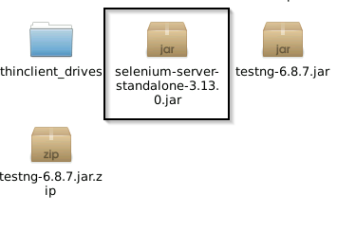

**Step 2: Downloading ChromeDriver**

2.1 Download the suitable chromedriver version. To do so, check the Google Chrome version on your system. Open Google Chrome >> Click on three dots >> Help >> About Google Chrome.

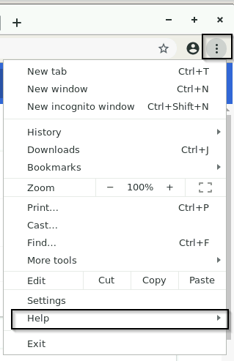



2.2 You will now be able to see the Google Chrome version.

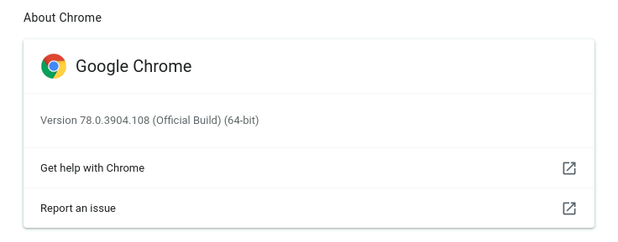

2.3 Go to [ChromeDriver downloads](https://chromedriver.chromium.org/downloads) and select the version as shown below.

**Note:**

If 90.0.4430.24 or 90.0.4430.72 or 90.0.XXX.XX

Download from <https://chromedriver.storage.googleapis.com/index.html?path=90.0.4430.24/>

Click on Linux 64 one.

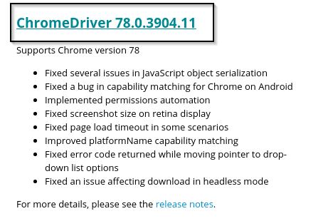

2.4 You will be redirected to the page shown below. Select for Linux zip file.

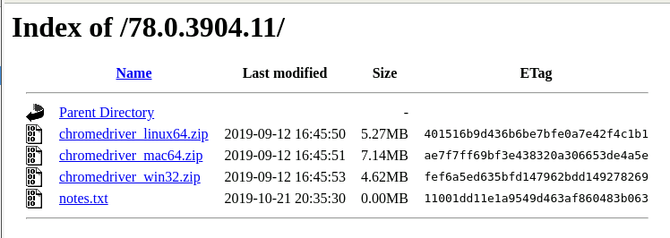



2.5 You can see the downloaded file in your system. You need to extract the zip file. Make sure to copy the path and keep it for use.

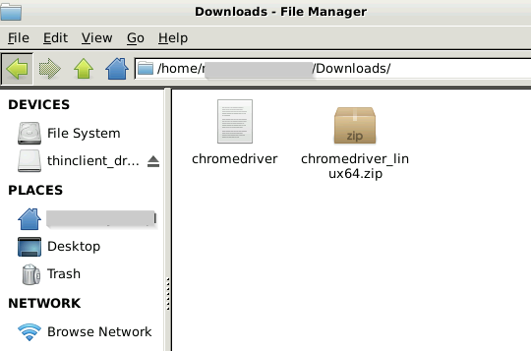



**Step 3: Integrating Selenium to Eclipse**

3.1 Open the Eclipse from your desktop.

Create a new Java project in Eclipse.

* File > New > **Java Project**
* Project Name : <Your App Name Here>
* Select JavaSE-1.8 for execution environment
* Leave defaults options > Next > Finish

Then Right click on the project and create a **package**.

* Select Project > Right Click > New > Package
* Package Name: <Your Package Name Here>
* Click on Finish

Once the package is created, create a new class inside the package.

Select the package you just created

* Right click > New > **Class**
* Name: <Your Class Name Here>
* Select Default options > Finish

3.2 Now, configure the build path by right clicking on the created project as shown below.

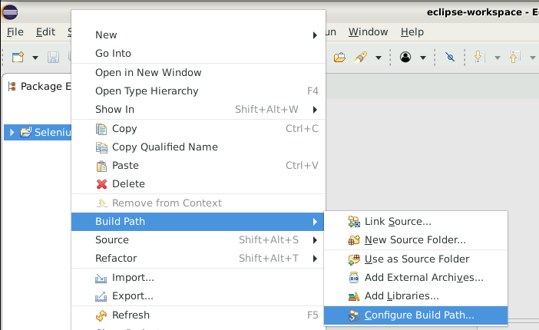

3.3 Click on Add external jar files for Selenium as shown below. Pop-up window will open up asking you to select a file. Select the Selenium jar file in the downloads section. 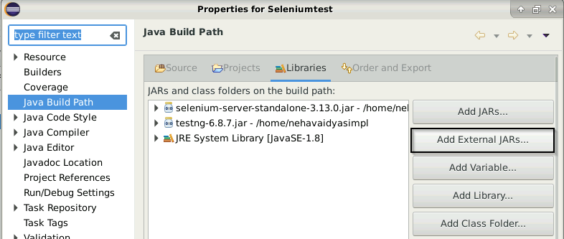

3.4 Click on **Apply and Close**.

3.5 You can see the referenced jar files as shown below.

